- Purpose
  - The purpose of this document is to describe the procedure for assembling a deck on an Optima Propane Burnisher with the dust control option.
- Scope
  - This SOP applies to all equipment assembly team members. The process applies to the following machines:
E012850EQM0600BE1200 – 27” Optima XR w/ Dust Control
E012852EQM0600BE1200 – 27” Optima XR w/ Dust Control without tank
E012860EQM0600BE1200 – 27” Optima XR w/ Clutch & Dust Control
E012862EQM0600BE1200 – 27” Optima XR w/ Clutch & Dust Control without tank
E012865EQM0600BE1200 – 27” Optima XR w/ Emissions & Dust Control
E012867EQM0600BE1200 – 27” Optima XR w/ Emissions & Dust Control without tank
E012875EQM0600BE1200 – 27” Optima XR w/ Emissions, Clutch, & Dust Control
E012877EQM0600BE1200 – 27” Optima XR w/ Emissions, Clutch, & Dust Control without tank
- Responsibilities
  - The operations manager/supervisor is responsible for enforcing this SOP.
- Materials
  - The proper materials needed for this process are listed on the sub-assembly work order.
  - Hand/Power Tools
- Definitions

- Procedure
  - Start by selecting a machine deck (11840) and laying it upside down on the assembly table.

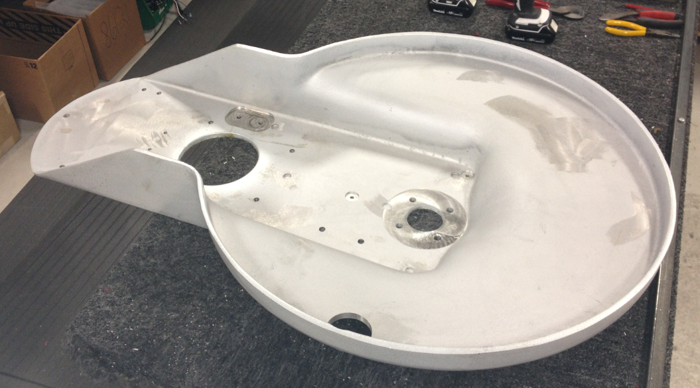

  - Prepare the deck for Dust Control by drilling out the appropriate holes. Use a hole saw (51mm) to cut out the hose opening. Drill a pilot hole before using the hole saw. Use a #7 drill bit to drill out the holes for the shroud standoffs and the dust basket. There are drill points to locate these. (Need photos)
  - Install the swivel caster (86118) into the appropriate hole on the back of the deck. Secure the caster to the deck with a locknut (81088).

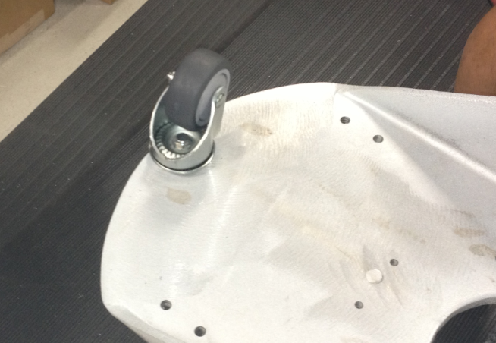

  - Get a set of wheels that were assembled using SOP EQ 075. Ensure they are set up for the 27” machine.

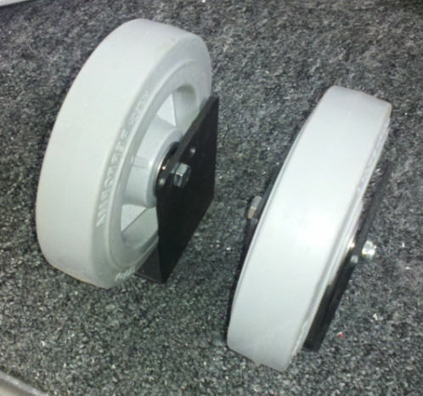

  - Fasten the brackets to the deck using 4 bolts (81089) and 4 lock washers (81067). Place the wheel brackets so that the head of the bolt faces towards the center of the machine. The nuts should face the outer edge of the deck.

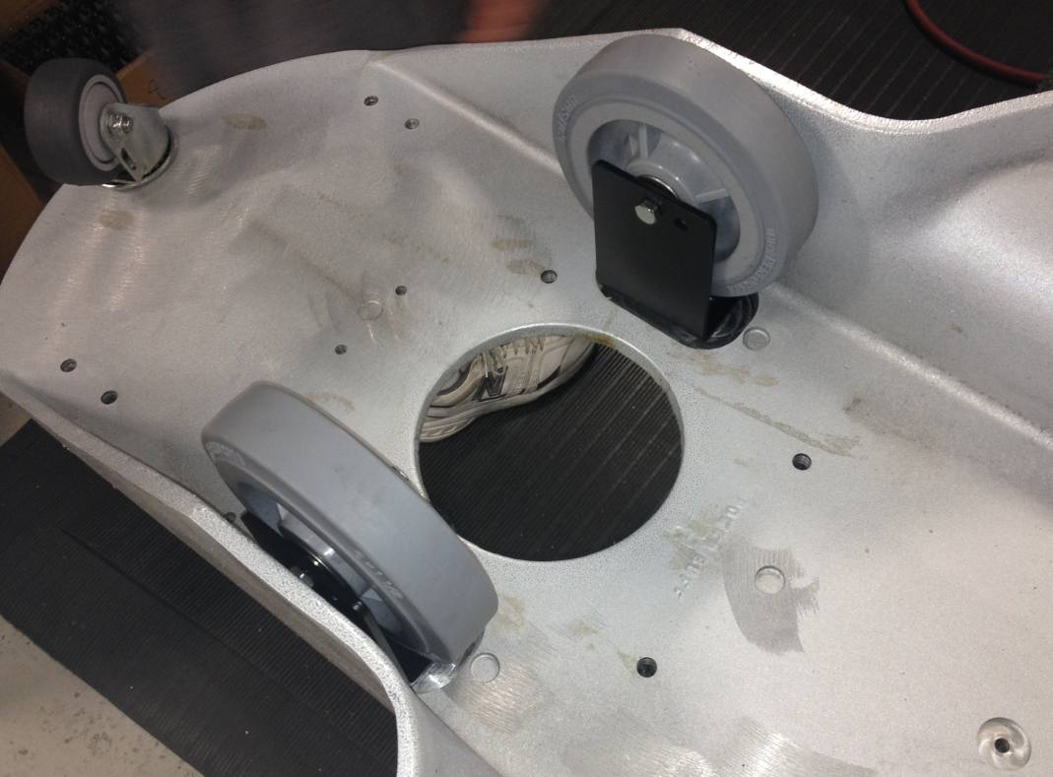
  - Attach the tensioner pulley (29048) to the deck using a bolt (83629), a washer (12447), and a lock washer (81066). Do not tighten the bolt all they way yet. Finger tight is all that is required at this point. The bolt head goes on the top side of the deck.

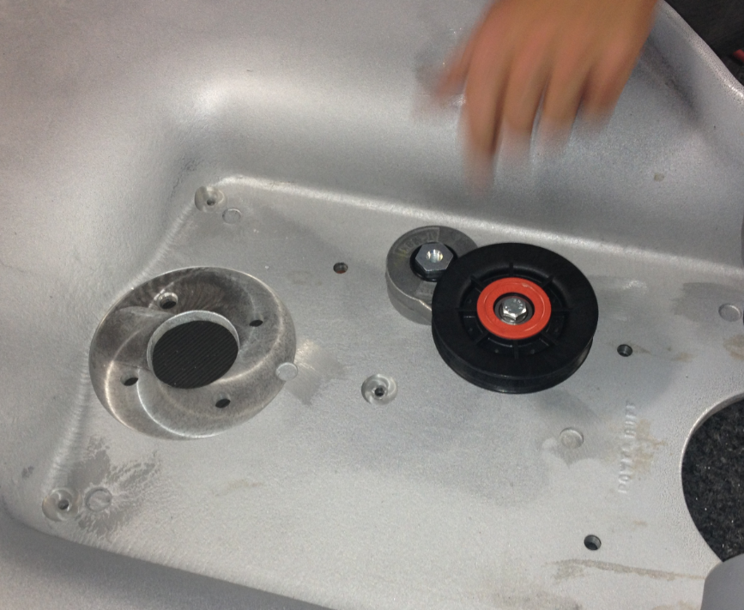

  - Bolt the center bearing housing (50208) into place. This is done using 4 bolts (10116), 4 washers (12447), and 4 lock washers (10117). The housing is bolted from the top side of the deck.

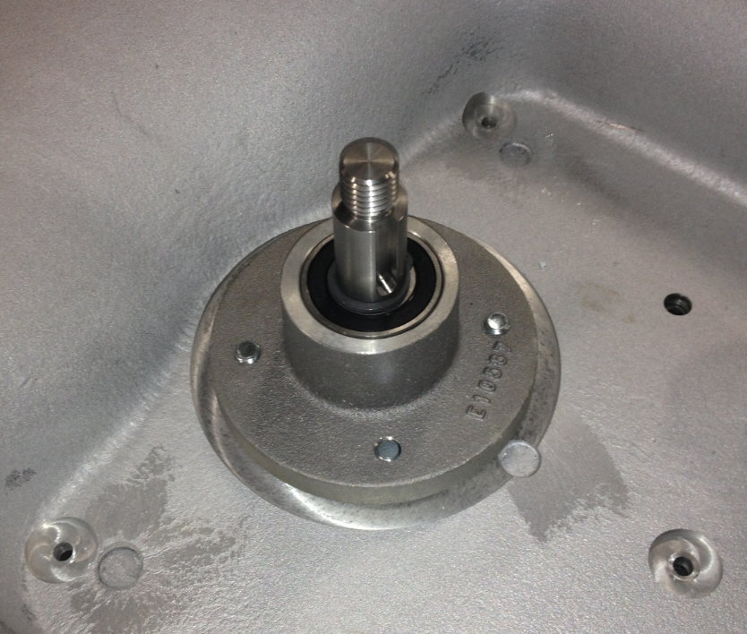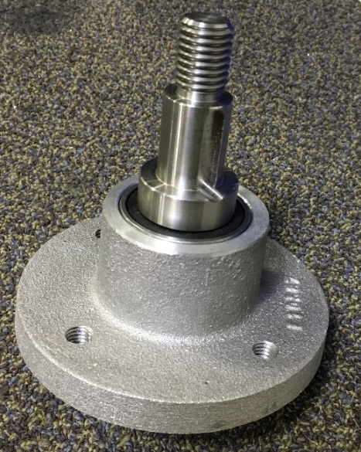

  - Tighten the bolts in the sequence shown. Use a torque wrench to tighten the bolts to 37ft-lbs.

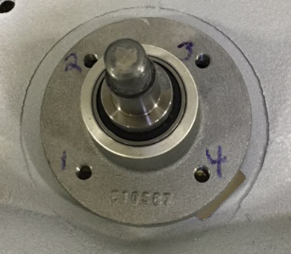

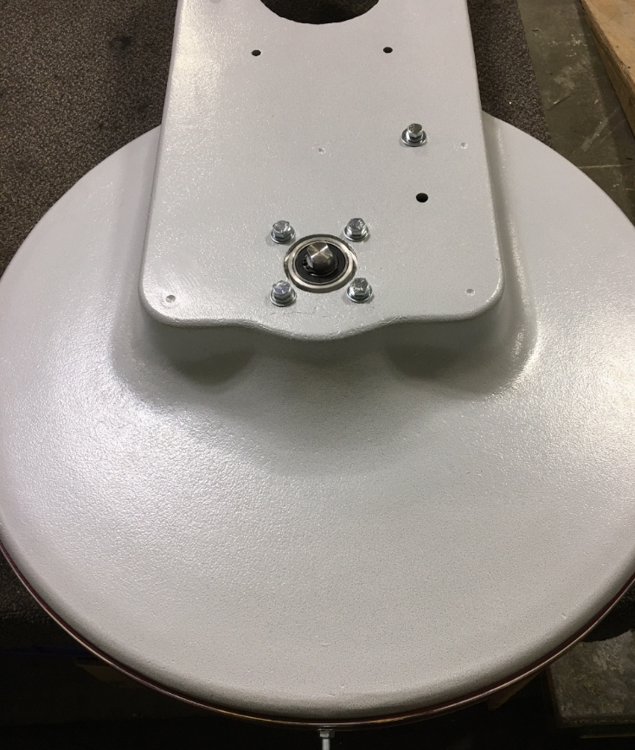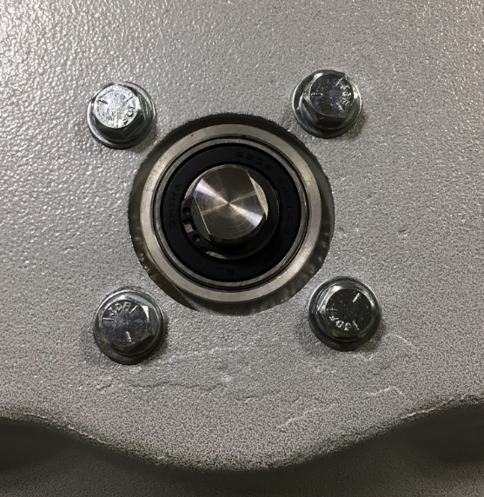
2nd

1st

4th

4th

3rd

1st

2nd

3rd

  - Get a front pulley assembly that was built using SOP EQ 073. Slide the assembly onto the main bearing shaft being sure that the keyways line up. Once it is on the shaft, insert the shaft key (12459). You may need to tap it with a hammer. Install the bushing so that the top of it is close to being flush with the shoulder just below the threaded portion of the shaft.
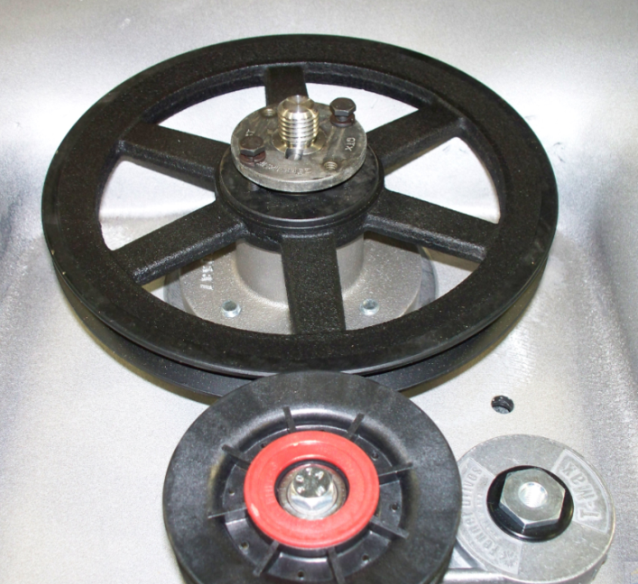
Screw and washer
Pulley
Bushing

  - Tighten the screws on the bushing. Do not tighten each one individually all the way. Alternate back and forth tightening each on little by little. This will ensure the assembly does not bind. Once it is tight, spin the pulley and make sure that the pulley stays level and does not wobble. If it does, loosen the screws and re-tighten them. Once tight, verify that the edge of the pulley is flush with the edge of the tensioner pulley. If not, loosen the screws in the bushing, move the assembly up or down the shaft as needed, then re-tighten.

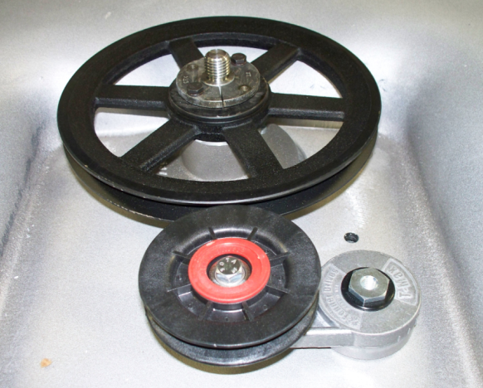
These edges should be flush

  - Install the belt (12979 for 27” machine / 12978 for 21” machine) around the pulley. This needs to be done now because once the standoffs are in place, it will be very difficult to get the belt on.

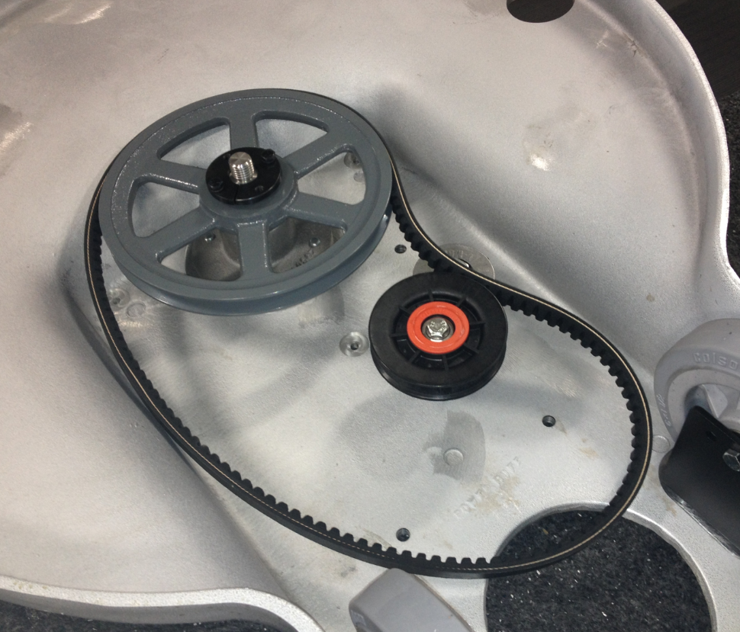

  - Bolt a standoff (88983) into each of the 3 locations shown using a bolt (89594), a lock washer (81078), and a flat washer (81713).

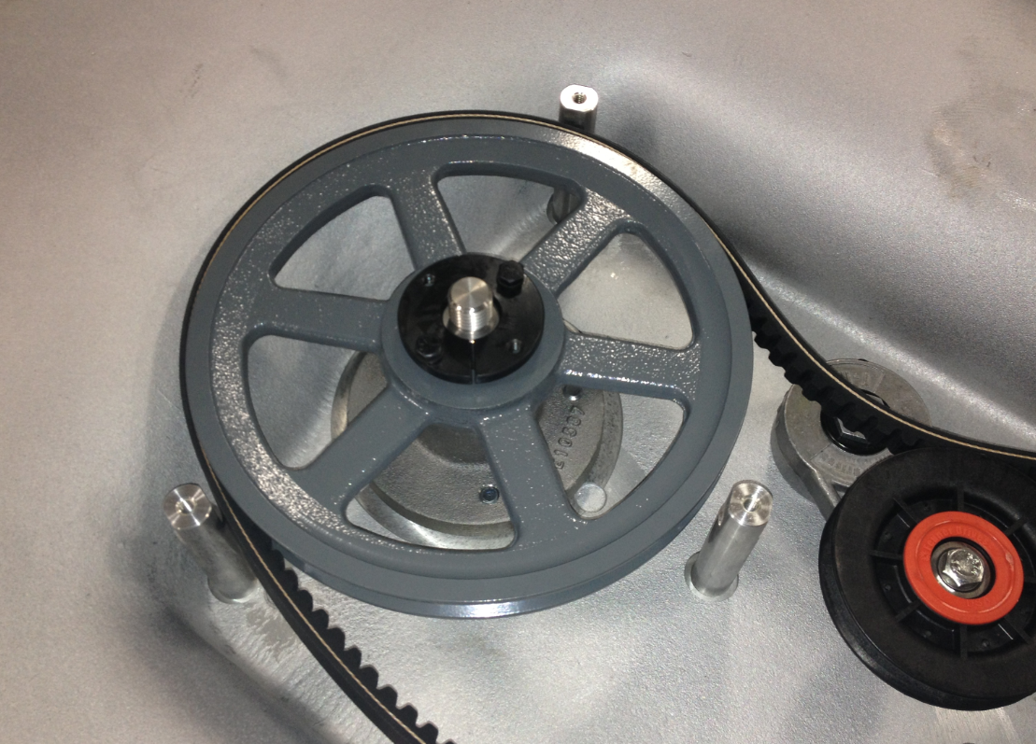

  - Flip the deck over so that the wheels are on the table. Clean the top side of the deck with a general purpose cleaner.

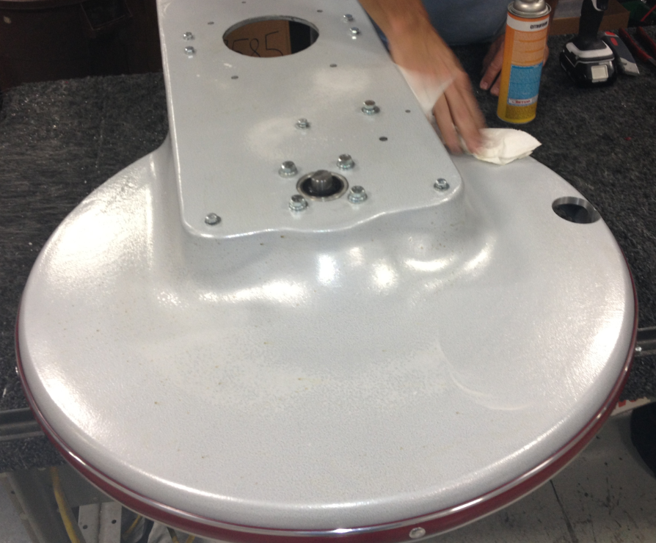

  - Fasten a filter bag weldment to the machine deck using 2 bolts (10122), 2 lock washers (81078), 2 flat washers (81713), and 2 nuts (83520). Verify that the vac port on the weldment points towards the front of the machine.

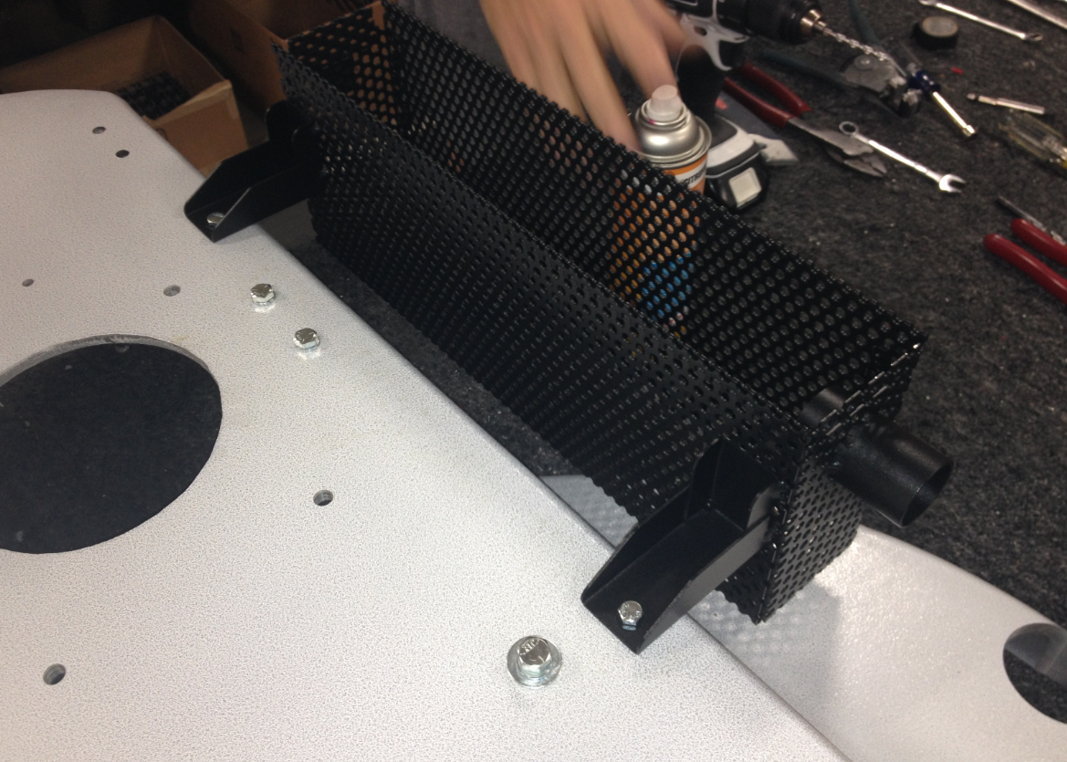

- References (optional section as needed)

- Training Guide

Functional Training Groups Requiring Training
Equipment Assembly Group

- SOP Change Control

Date of Change | Reason for Change
11/19/2013 | This is the first version of the S.O.P. hence there are no revisions to this document.
1/15/2018 | Added Responsibilities section and updated bearing housing shimming method.
4/4/2018 | Added updated bearing shimming and bolt torque specs.
5/4/2018 | Updated for the Optima XR upgrades
3/21/2025 | Removed work center notes and updated for Onyx items

Approvals

Submitter/Author Approval:__________________________________ Date:______________________

Management Approval:______________________________________ Date:______________________

QAU Approval:_____________________________________________ Date:______________________

